3. Find all existing issues with the code snippets presented below. It is highly important to try working this out on paper by tracing through the statements and then input the code into your IDE. Run it to see if you are correct, and then see if you can fix the code.

a)

b)

c)

d)

e)

4. What is the output of the following code fragments? Remember to try working this out on paper by tracing through the statements and then input the code into your IDE. Run it to see if you are correct, and then see if you can fix the code.

a)

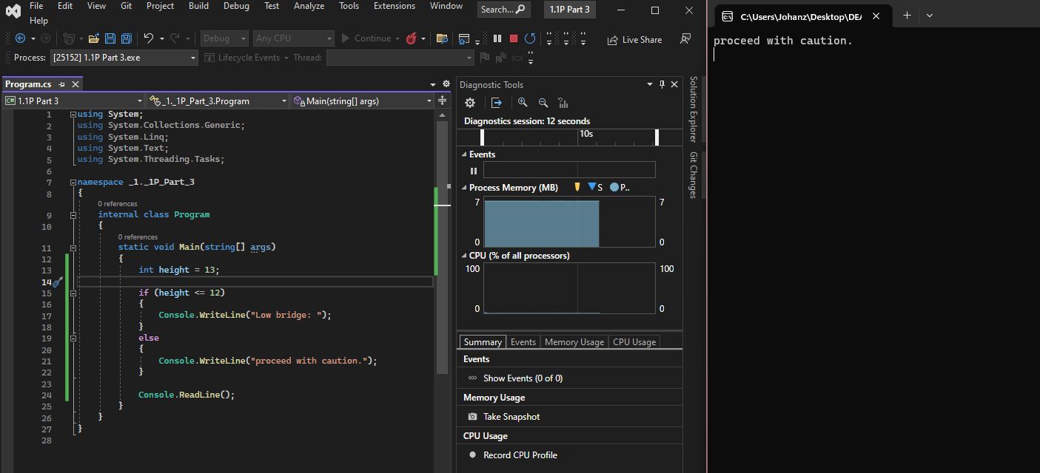

b)

c)

